Kushal Basaula

kUSHAL.BASAULA@STUDYTAFENSW.EDU.AU

Delta Track Social Research Organization

Table of Contents

Client overview: 2

Cloud Service Model: Public Cloud: 3

Cloud Service Type: IaaS with PaaS Integration: 3

Azure Architecture Design Products, Services, and Solutions: 4

Azure Products and Services: 4

Azure Solutions: 5

Cloud infrastructure diagram: 5

Expected Costs: 6

Conclusion: 7

References 7

# Client overview:

Delta Track Social Research Organisation, a non-profit, operates a website that gives worldwide development data. Amanda Knights, a researcher with the organisation, built the site with PHP and MySQL on a Linux Ubuntu server that was first handled by a commercial hosting business. Amanda is searching for a more secure, scalable, and high-performance solution leveraging Azure services as traffic and performance difficulties increase, as well as a recent attempted ransomware compromise. The purpose is to provide secure connections, high availability, and secure the website for higher usage.

Amanda's primary requirements are:

* Enhanced website functionality as a result of higher traffic.
* Protect hosting against security breaches with a strong defence.
* Load balancing ensures high website availability.
* Secure credentials storage and safe access to the MySQL database.
* The capacity to utilise a template to duplicate the deployment for later usage.

# Cloud Service Model: Public Cloud:

For Delta Track, a Public Cloud model is the best option. Delta Track's objectives are in line with the **scalability, flexibility, and affordability** that public cloud providers like Azure deliver. The public cloud is the greatest choice since Amanda's website is becoming more and more popular and needs a scalable solution with less physical infrastructure administration. Many managed services are accessible through Azure's public cloud, which will lessen Amanda and her team's administrative workload.

# Cloud Service Type: IaaS with PaaS Integration:

Based on the Client Scenario, the suitable choice should be a combination of Infrastructure as a Service (IaaS) and Platform as a Service (PaaS) for Delta Track.

* **IaaS** gives Amanda complete control over the Virtual Machines (VMs) that are running the PHP application, enabling her to configure, manage, and maintain the environment. IaaS also ensures administrative control over security settings, giving Amanda the flexibility to have overall control managing the traffic spikes.
* Whereas, **PaaS** takes care of the underlying infrastructure by using Azure Database for MySQL as a managed service, which improves performance and offers built-in backups and security features like encryption.

# Azure Architecture Design Products, Services, and Solutions:

## Azure Products and Services:

* **Azure Virtual Machines (VM):** Offers a highly configurable computing environment for MySQL and PHP applications. It provides control and flexibility over the infrastructure that's underneath.
* **Azure Load Balancing**: Ensures great website availability and scalability by distributing traffic among several virtual machine instances.
* **Azure Public Subnet:** Enables people to view the website from the internet by giving the virtual machine instances internet connectivity.
* **Azure Private Subnet**: Isolates the database and virtual machine instances from the public internet by providing a secure network environment.
* **Azure Network Security Groups (NSGs):** Adds an extra degree of protection by managing incoming and outgoing network traffic to the virtual machine instances.
* **Azure MySQL Database:** Provides a controlled, scalable, and safe database solution for data storage and retrieval.
* **Azure Key Vault:** Safely stores and maintains secrets, including database connection strings.
* **Azure Monitor & Log Analytics:** Offers logging and monitoring tools to track resource health and performance.
* **Azure Backup & Disaster Recovery** ensures data recovery and availability by backing up the database to another location.
* **Azure Resource Manager (ARM) Templates:** Facilitates repeatable and consistent infrastructure setup, reducing replication and administration.
* **Two availability zones:** One zone has hosted the VM with Azure monitor & log analytics and ARM templates. While another zone is attached with A VM which is connected to an Azure SQL managed database and key vaults that store sensitive information like database connections strings.
* **Support with Azure**:Azure Support, which provides direction and technical support, is what Delta Track has chosen to ensure seamless operations and prompt troubleshooting.

## Azure Solutions:

* **High Availability:** The website has high availability by virtue of the combination of multiple VM instances connected by Azure Load Balancer in both ends.
* **Security:** Regular monitoring, Azure Key Vault, and Network Security Groups significantly contribute to the resources' security. And they are on Zone 2 which is securely connected with NSG and secure connectivity.
* **Scalability:** It is straightforward to scale resources to meet growing demand when Azure Virtual Machines and databases are used.
* **Disaster Recovery**: at the event of outage, having a backup database at a distant location (Australian east and Southeast Australia) serves as an emergency recovery plan.

# Cloud infrastructure diagram:

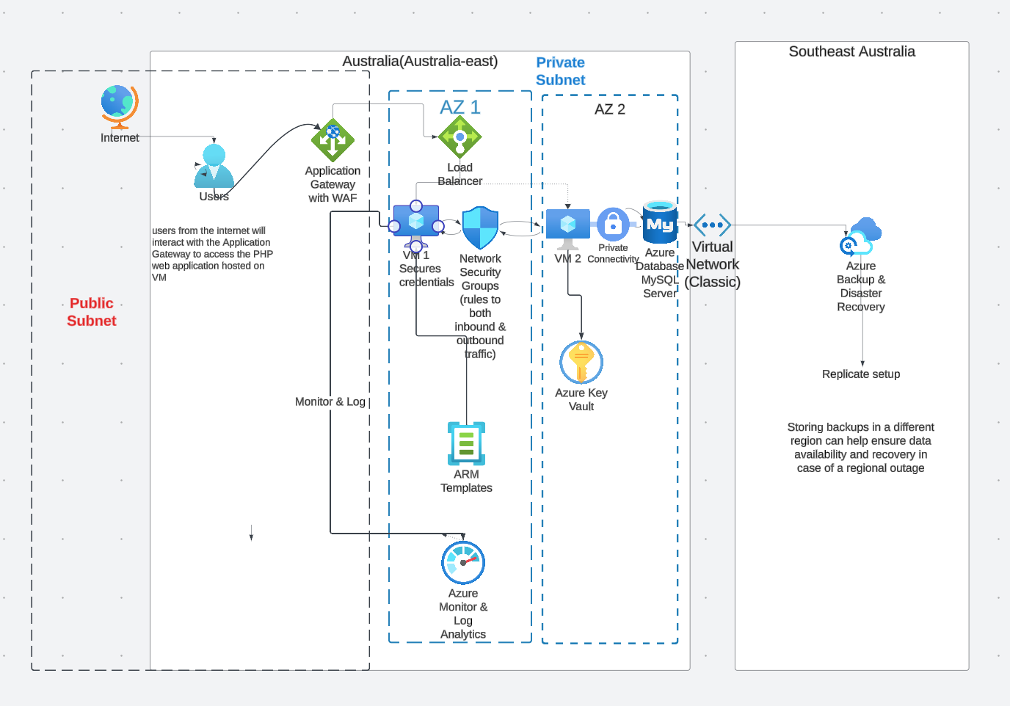

# Expected Costs:

### Microsoft offers qualified non-profits Azure credits. Azure services valued at $3,500 (or its equivalent in local currency) can be granted to organisations on an annual basis. This enables non-profits to utilise free cloud computing, storage, database, and other services up until the grant is exceeded.

### Discounted pricing is also offered to non-profits who want more Azure services than what is covered by the grant and many more offers. This would be a huge help for Delta Track to scale with increasing demand and enhance their online offerings without taxing their resources.

### 

# **Conclusion:**

# This paper describes a Microsoft Azure-based cloud solution that is both safe and scalable for Delta Track. It leverages managed services for the database and mixes PaaS and IaaS services to offer flexibility and control. Azure virtual machines, load balancers, MySQL databases, key vaults, and monitoring tools are some of the essential parts. High availability, security, scalability, and disaster recovery are all guaranteed by the system. For Delta Track's expanding requirements, Microsoft's non-profit Azure credits programme presents a feasible alternative due to its ability to lower expenses.

# **References**

* Microsoft. (n.d.). *Azure grant for nonprofits*. <https://www.microsoft.com/en-us/nonprofits/azure>
* Microsoft. (n.d.). Azure security documentation. <https://docs.microsoft.com/en-us/azure/security/>
* Microsoft. (n.d.). *Microsoft Azure pricing calculator: Azure cost estimation*. Microsoft Azure. Retrieved from <https://azure.microsoft.com/en-us/pricing/calculator/>
* Microsoft. (n.d.). *Microsoft documentation on Azure virtual machines*. Microsoft Learn. Retrieved from <https://docs.microsoft.com/en-us/azure/virtual-machines/>
* Microsoft. (n.d.). *Microsoft documentation on Azure database for MySQL*. Microsoft Learn. Retrieved from <https://docs.microsoft.com/en-us/azure/mysql/>
* Microsoft. (n.d.). *Azure Key Vault security best practices*. Microsoft Learn. Retrieved from <https://docs.microsoft.com/en-us/azure/key-vault/general/best-practices>
* Lucid. (n.d.). *Lucidchart: Diagramming application*. Lucid. Retrieved from <https://lucid.app/lucidchart/>
* Microsoft. (n.d.). *Azure pricing calculator*. Microsoft. Retrieved from <https://azure.microsoft.com/en-au/pricing/calculator/>